**Gaurav Thorat**

**002957343**

**INFO – 6205 Section 6**

**Task: -** To implement height weighted Quick Find with Path Compression.

The task was divided into three parts,

1. To implement height weighted Quick Find with Path Compression and complete the implementation of all test cases UF_HWQUPC.
2. Using UF_HWQUPC create a Union Find implementation that takes n input and generates pairs.
3. Third determine pairs.

Step 1 – Solution

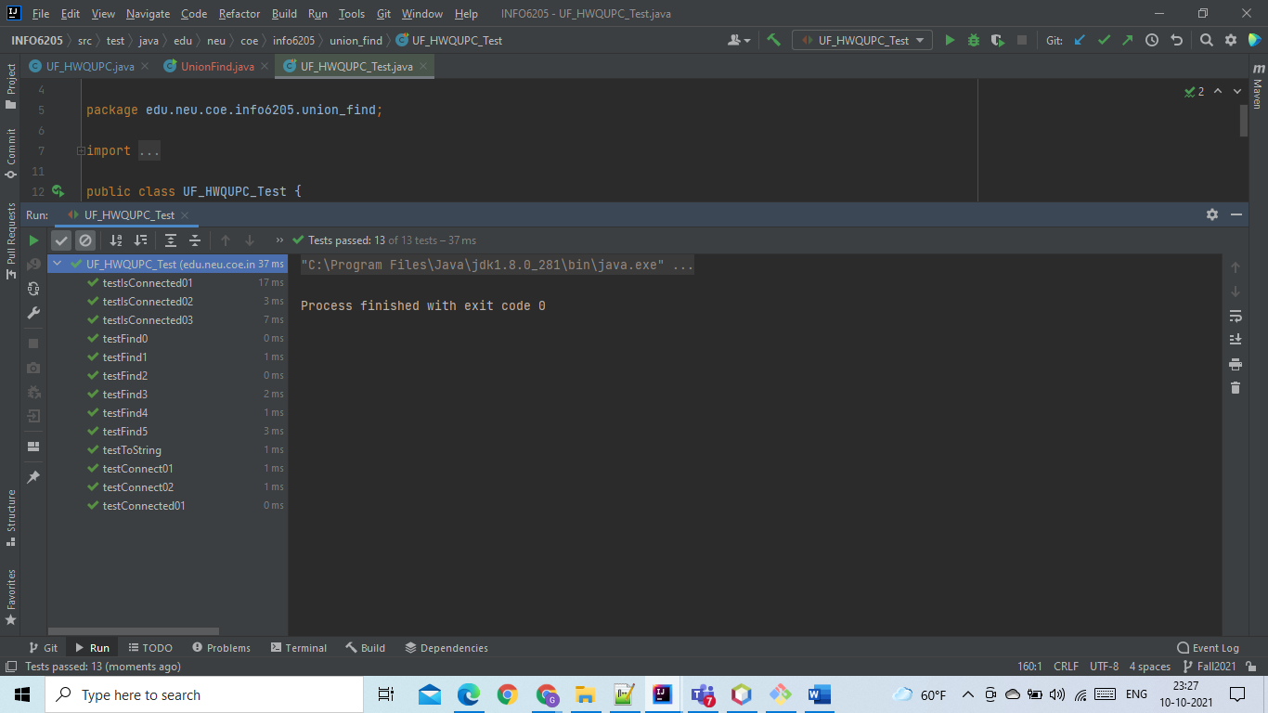

Passing all the test cases.

Step 2 – Solution

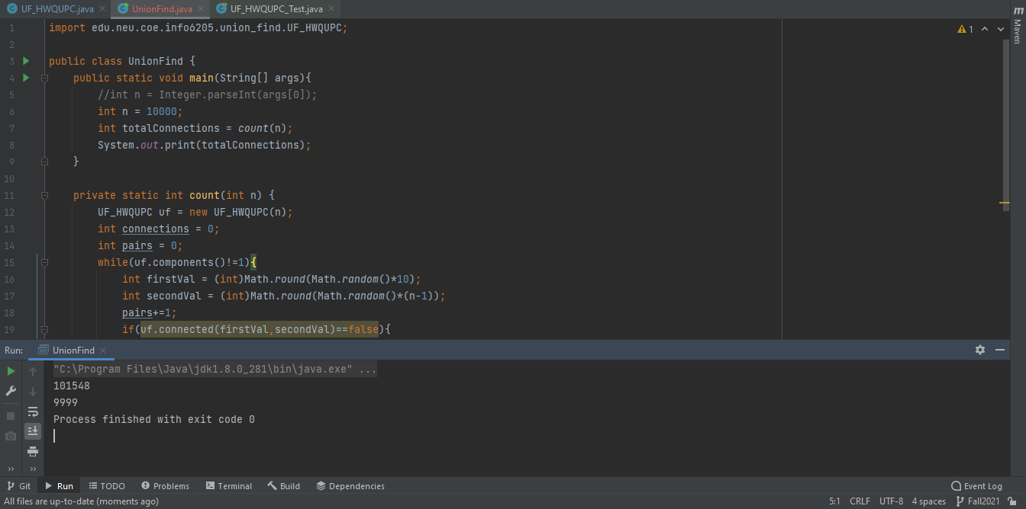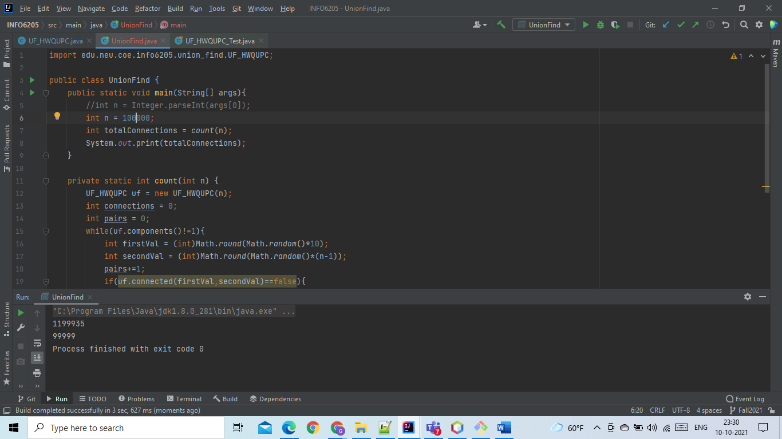

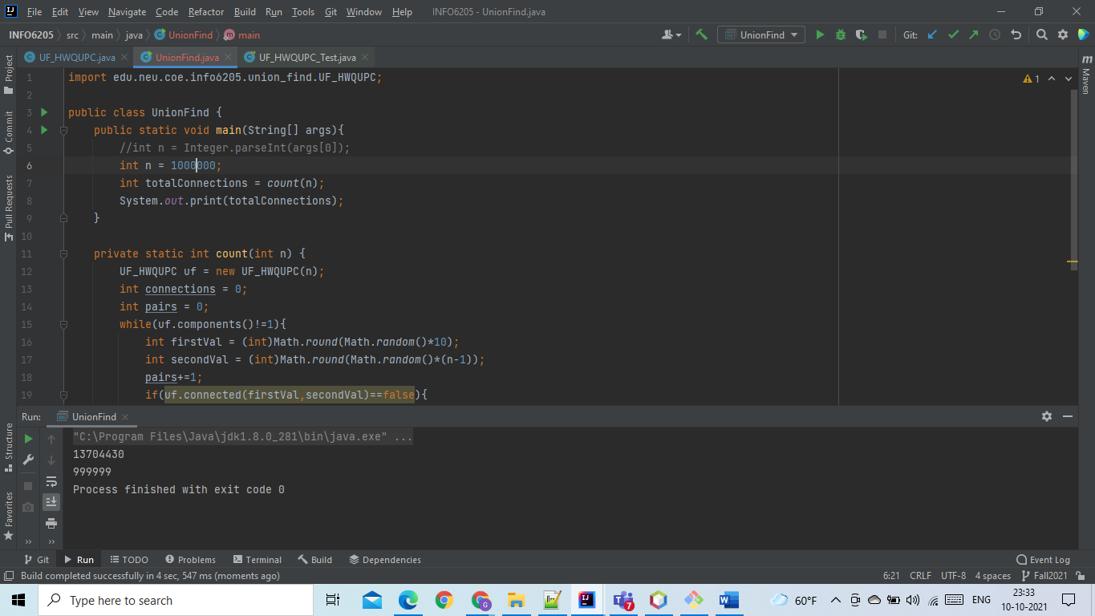

Relationship Between N, M (Pairs Generated) and K(Connection Made)

|  |  |  |
| --- | --- | --- |
| N | M (Pairs Generated) | K(Connection Made) |
| 10000 | 101548 | 9999 |
| 100000 | 1199935 | 99999 |
| 1000000 | 13704430 | 999999 |

The relation between N and K is N-1 as there would always be N-1 connections made between nodes.

The relation between N and M is (M ~ N * 10). For eg, in 10 nodes if each node is connected to every other node it would create 9 connections or 9 pairs which is almost 10.

Hence, the relation between N and M is M ~ N * 10.

Following are charts for illustration,

